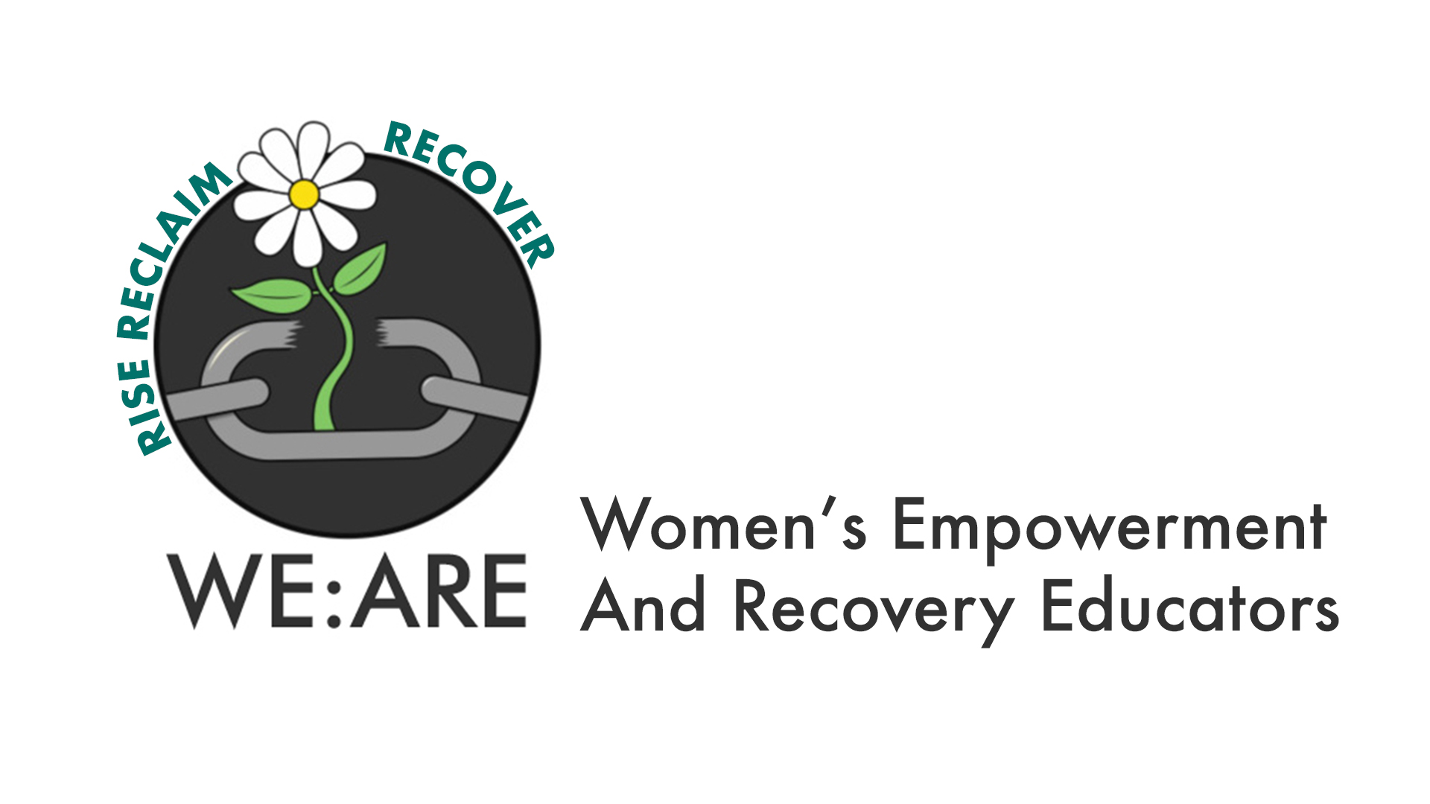
Job Description

Job Title: Administrative Assistant

Job Purpose: To provide administrative support to WE:ARE, enabling the team and the Board of Trustees to operate effectively and efficiently.
Hours: 12 hours per week
Fixed Term until December 2026 (Subject to probationary period)
Funded by National Lottery Reaching Communities
Salary: £13 per hour
Responsible to: Project Manager

Place of Work Hybrid Working

Closing date: 5pm Monday November 13th 2023
Interview date: Wednesday November 22nd 2023

Are you looking for a rewarding role working for an organisation supporting women to Rise Reclaim and Recover.
WE:ARE is a well-established, innovative South Birmingham based project providing a pathway of Awareness & Empowerment Programmes for women who have been subjected to domestic abuse. The underpinning message throughout the programmes is a valuing of survivor’s own strengths, resources and the coping skills which have helped them to survive thus far.
Our values are Compassion and Commitment, Hope and Healing, Innovate and Influence, Educate and Empower all with the aim of supporting women to live a life free from abuse.

These posts are covered by a Genuine Occupational Requirement (Schedule 9; Equality Act 2010) and women only need apply.
Please note all successful candidates will be subject to a Disclosure and Barring Service Check before commencing their employment.
About You:
We are seeking a self-motivated, flexible, skilled Administrative Assistant to join our small but dynamic team. You are passionate about working for an organisation supporting survivors of domestic abuse and want to play a role in their journey from Leaving to Healing.
Flexible working is welcomed at WE:ARE with a mix of remote and location-based working. We are all women with busy lives and families, and we understand that flexibility can be crucial in supporting women in the workplace.
Working for WE:ARE
Commitment to safeguarding WE:ARE is committed to safeguarding and promoting the welfare of vulnerable adults, children and young people and expects all staff and volunteers to share this commitment.
Employees must ensure that all practice is delivered within the framework of Safeguarding Adults and Children.
Equality and diversity WE:ARE is a feminist organisation devoted to equal opportunities and a fairer society where everyone has the opportunity to fulfil their potential and diversity is valued. WE:ARE will ensure that all employees, applicants for employment and volunteers are treated fairly and with respect at all stages of their employment or service.
General Data Protection Regulation (GDPR) WE:ARE is committed to protecting the rights and freedoms of all individuals in relation to the processing of their personal data.
All employees are required to comply with GDPR procedures and principles.

Key responsibilities
- Provide admin support to the project manager and programme lead as required.
- Assist with production of reports to facilitate WE:ARE’s monitoring and evaluation systems procedures.
- Prepare documents for programme delivery including photocopying, printing, and filing.

- Organise and maintain electronic filing systems and any other systems as required.
- Creation of digital forms to collate information for production of statistical reports.
- Assist with social media updates to promote activities and programmes.
- Production of event posters and other promotional materials.
- Support on awareness events and group celebration events.
- Provide administrative support to the Board of Trustees bi-monthly meetings and ad hoc sessions. This includes: agreeing dates, arranging venues or video conferencing bookings, agreeing the agenda with the chair; circulating agenda and papers in advance, minute taking and follow up of action log.
- Ensure the Charity’s records are up to date, secure and well maintained, including electronic and hard copy records. To ensure the Charity’s policy on record keeping is followed, including timely destruction of records in line with the policy.
- Ensure the Charity’s financial records are up to date, secure and well maintained, including invoices, orders, bank statements, monthly financial spreadsheets, annual accounts, and copies of any financial returns.
- Maintain the register of policies, ensuring that policies are highlighted for review ahead of the appropriate dates, and liaising the staff and Trustees regarding the updating of policies, or drafting new policies as required.
- Ensure that the Charity’s records at the Charity Commission and Companies House are up to date and accurate, liaising with the project manager and/or Trustees as appropriate where updates are required.
- Undertake ad hoc returns as required by statutory organisations, e.g., HMRC, in conjunction with staff / trustees as appropriate.
- Attend and participate in regular training when required.
- Attend and participate in regular supervision, staff, and other meetings.

This role includes an expectation that the post holder will perform generic duties as a team member to ensure the effective and efficient running of WE:ARE services.
This job description is an accurate reflection of the responsibilities of the post at the time of writing but may be subject to change from time to time to meet the changing requirements of the organisation.

Person Specification

 |  | FORM | INTERVIEW | TEST

QUALIFICATIONS

1 | Evidence of continuing professional development and relevant qualifications/training. | X | X

 |  | FORM | INTERVIEW | TEST

COMMITMENT AND UNDERSTANDING:

1. | An understanding of women’s issues and feminist principles, in particular around the issues of domestic violence and its implications for women and children. | X | X
2. | Commitment to services for women and children affected by domestic violence and to working withing WE:ARE ethos, policies and procedures. | X | X

SUBSTANTIAL EXPERIENCE OF: |  | FORM | INTERVIEW | TEST
1. | Administrative skills including the ability to identify administrative needs and develop and maintain appropriate systems to meet them. | X | X
2. | IT systems and programmes including the use of Word, Excel, Google Forms (or similar) and Canva. | X | X | X
3. | Maintaining social media accounts, websites and content production. | X | X
4. | Developing and reviewing policies. | X | X
5. | Maintaining financial records using Excel. | X | X
6. | Creating digital forms and producing reports from the data collected. | X | X
7. | Providing support to a Board of Trustees or similar committee including the ability to take accurate minutes. | X | X
8. | Maintaining accurate and up-to-date records in compliance with regulators including Charity Commission, Companies House and HMRC. | X | X
9. | Producing promotional documents. | X | X | X

Skills and abilities |  | FORM | INTERVIEW | TEST
1 | Ability to maintain strict confidentiality and work within data protection guidelines. | X | X
2 | Able to build and develop supportive relationships with victims of abuse, showing sensitivity for others’ viewpoints and valuing diversity. | X | X
3 | Ability to work effectively as a member of a team and on own initiative. | X | X
4 | Able to work under pressure and to plan and prioritise time and resources when competing demands arise. | X | X
5 | Able to maintain professional boundaries and know when to seek management guidance and support when required. | X | X
6. | Ability to build and maintain good working relationships with colleagues to foster team spirit, commitment to the team and achievement of shared goals. | X | X

Personal Attributes |  | FORM | INTERVIEW | TEST
1. | Non-judgmental, non-directive and anti-discriminatory approach towards victims and survivors of abuse | X | X
2. | Organised, proactive and consistent delivery of work | X
3. | High level of self-motivation and integrity and an ability to think creatively with a ‘can-do’ attitude that can inspire others | X | X

